Search the “COVID news” dataset in the past 5 yrs for each state (see GeoIDs - State.csv for state list).

Step 1: download data from <https://trends.google.com/trends/explore?date=today%205-y&geo=US-AL&q=COVID%20news>

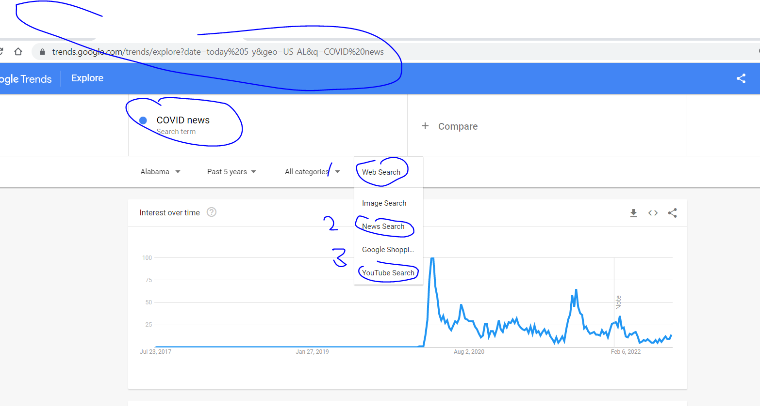

1. You should download this state by state. **More specifically, you should download the data for each state** (instead of using the “+Compare” function).
2. For this specific search key word, you need to download “Web Search”, “News Search”, and “ YouTube Search”

Step 2: add a column of statename and statefips (see GeoIDs - State.csv for state list) to each CSV file and append all the CSV file together **(up-bottom appending)**

1. Append each state based on **up-bottom appending**
2. Append the search results (“Web Search”, “News Search”, and “ YouTube Search”) for the same state at the same week **side-by-side**

